## Scenario 2

In this section we discuss a network with three connected nodes, where packets come with batches arrival and each batch consists of one packet or two packets can be divided into two priorities: high priority (HP) and low priority (LP). Both types of packets require the same amount of energy. The first node is an "entry node", the second node is an "exit node", and the third node is a "control node". After passing through the control node, packets are directed to the correct path to the exit node and leave the network. Impatient packets may leave the queue at any time. Whenever a node is ready to serve a packet, it first checks the energy queue for sufficient energy units. If there are not enough energy units, the packet may use a regular battery with a given probability. The model diagram, state balance equations, iterative algorithm, and performance measures are provided below.

### Model diagram

In scenario 2, as illustrated in Fig. 3 - 5, we have an open network model with three nodes. Each node in the network consists of a finite packet queue, a finite energy queue, a regular battery, and a single server. The packet queue size is denoted by $N$, $(0<N<∞)$, the energy queue size is denoted by $K$, $(0<K<∞)$, and the regular battery has an unlimited supply of energy. HP and LP packets have the same energy requirement, which is one energy unit. The arrivals of HP and LP packets, and the arrival energy units of each node $n$, follow a Poisson process with specific arrival rates $λ_{H}$, $λ_{L}$ and $β_{n}$, respectively. In addition, for each node n in the network, we consider the sum of external or internal HP (LP) packet arrivals as a Poisson process and denote its arrival rates with $λ_{Hn}$ ($λ_{Ln}$). The waiting time for each HP (LP) packet in node n's queue is determined by an exponential distribution with corresponding rates $α_{Hn}$ ($α_{Ln}$). Node n's service time for each HP (LP) packet is assumed to follow an exponential distribution with rates $μ_{Hn}$ ($μ_{Ln}$), respectively. We assume that when the energy queue lacks the necessary harvested energy to support an HP or LP packet, the regular battery will be used based on probabilities $θ_{Hn}$ and $θ_{Ln}$. Additionally, when a packet finishes service at node i, it is either removed from the network or forwarded to the next node j with an assigned routing probability $r_{ij}$, where $i, j=1, 2, 3$ and $i≠j$. However, there are some restrictions on the routing policy. First, packets cannot be routed from the exit node to the entry node. Second, packets from the entry and exit nodes are only permitted to pass through the control node once before being forwarded to the previous node.

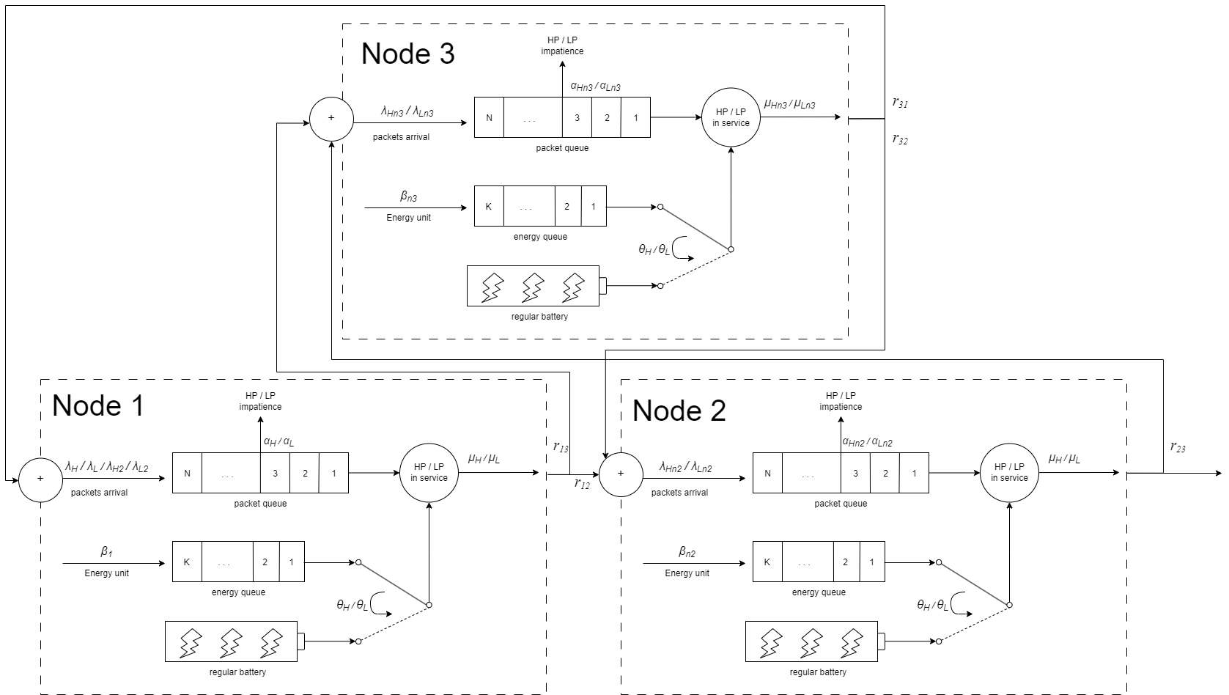

Fig. 3 - 3: The model diagram for scenario 2

### State balance equations

To achieve a simplification in the derivation, we assume that each node in the network is independent. We can represent node $n$ as a four-dimensional Markov chain with the state $(i_{n}, j_{n}, x_{n}, y_{n})$, where $i_{n}$ represents the number of HP packets in node $n$, $j_{n}$ represents the number of LP packets in node $n$, $x_{n}$ represents the number of harvested energy units in the energy queue at node $n$, and $y_{n}$ represents the server status and the energy resource being used in node $n$. Note that $y_{n}$ can take five values: (1) " $0$" indicates that the server is idle; (2) " $1$" indicates that an LP packet has entered the server and consumed one energy unit from the energy queue; (3) " $2$" indicates that an HP packet has entered the server and consumed one energy unit from the energy queue; (4) " $3$" indicates that an LP packet has entered the server and consumed one energy unit from the regular battery; (5) " $4$" indicates that an HP packet has entered the server and consumed one energy unit from the regular battery. The steady state probability of the system is represented by $π(i_{n}, j_{n}, x_{n}, y_{n})$, and the state space is defined as follows:

$$S_{n}=\left\{\left(i_{n}, j_{n}, x_{n}, y_{n}\right)\right| 0≤i_{n}+j_{n}≤N, x_{n}=0, y_{n}=0;$$

$$i_{n}+j_{n}=0, 1≤x_{n}≤K, y_{n}=0;$$

$$1≤i_{n}+j_{n}≤N+1, j≥1, 0≤x_{n}≤K,y_{n}=1、3;$$

$1≤i_{n}+j_{n}≤N+1, i≥1, 0≤x_{n}≤K,y_{n}=2、4\}$ (3-55)

As a result, we can calculate the total count of possible states $\left|S_{n}\right|=\left(2K+\frac{5}{2}\right)N^{2}+\left(6K+\frac{15}{2}\right)N+5K+5$ 
.

In addition, the analysis of the arrival rate of each node should take into account five internal arrival rates.

To begin with, we calculate the arrival rates of HP and LP packets from node 1 to node 3.

$\left\{\begin{aligned} λ_{H13}=\frac{(λ_{H}+λ_{H2}*2)(1-P_{tl_H-1})r_{13}}{(λ_{H}+λ_{H2}*2+λ_{H31})(1-P_{tl_H-1})}{TH}_{H-1} \\ λ_{L13}=\frac{(λ_{L}+λ_{L2}*2)(1-P_{tl_L-1})r_{13}}{(λ_{L}+λ_{L2}*2+λ_{L31})(1-P_{tl_L-1})}{TH}_{L-1}\end{aligned}\right.$ (3-56)

The equation's right-hand side has two parts. The first part shows the percentage of HP or LP packets completing service in node 1 and then directed to node 3. The denominator shows the total HP or LP packet arrival rate for node 1, including the unblocked arrival rates from outside and node 3. The numerator represents the unblocked arrival rate from outside, which is directed to node 3 according to $r_{13}$. It should be noted that in this scenario, only external packets can be routed to node 3, as each packet can visit node 3 only once.

Next, we calculate the arrival rates of HP and LP packets from node 3 to node 1.

$\left\{\begin{aligned} λ_{H31}=\frac{λ_{H13}(1-P_{tl_H-3})}{(λ_{H13}+λ_{H23})(1-P_{tl_H-3})}{TH}_{H-3} \\ λ_{L31}=\frac{λ_{L13}(1-P_{tl_L-3})}{(λ_{L13}+λ_{L23})(1-P_{tl_L-3})}{TH}_{L-3}\end{aligned}\right.$ (3-57)

The equation's right-hand side has two parts. The first part shows the percentage of HP or LP packets that have completed their service at node 3 and will be sent back to node 1. The denominator shows the total HP or LP packet arrival rate of node 3, which includes the unblocked arrival rates from node 1 and node 2. The numerator indicates the unblocked arrival rate from node 1. It should be noted that all packets that pass through the control node will be forwarded to the previous node, so the packets that have finished service at node 3 will be routed back to node 1.

Next, we calculate the arrival rates of HP and LP packets from node 1 to node 2.

$\left\{\begin{aligned} λ_{H12}=\frac{(λ_{H}+λ_{H2}*2)(1-P_{tl_H-1})r_{12}+λ_{H31}(1-P_{tl_H-1})}{\left(λ_{H}+λ_{H2}*2+λ_{H31}\right)(1-P_{tl_H-1})}{TH}_{H-1} \\ λ_{L12}=\frac{{(λ}_{L}+λ_{L2}*2)(1-P_{tl_L-1})r_{12}{+λ}_{L31}(1-P_{tl_L-1})}{\left(λ_{L}+λ_{L2}*2+λ_{L31}\right)(1-P_{tl_L-1})}{TH}_{L-1}\end{aligned}\right.$ (3-58)

The equation's right-hand side calculates the HP or LP packet arrival rates from node 1 to node 2. The first term indicates the proportion of HP or LP packets finishing service in node 1 and moving on to node 2. The denominator part represents the total HP or LP packet arrival rate of node 1, which includes those unblocked arrival rates from outside and node 3. The numerator part represents the unblocked arrival rates from outside that is routed to node 2 based on $r_{12}$ and the unblocked arrival rates from node 3. It is important to note that each packet passing through the control node will be forwarded to the previous node, so the packets that have completed service at node 1 will be routed back to node 2.

Next, we calculate the HP and LP packet arrival rates from node 2 to node 3.

$\left\{\begin{aligned} λ_{H23}=\frac{λ_{H12}(1-P_{tl_H-2})}{\left(λ_{H12}+λ_{H32}\right)(1-P_{tl_H-2})}\frac{(λ_{H}+λ_{H2}*2)r_{12}r_{23}}{{λ_{H31}+λ}_{H}r_{12}}{TH}_{H-2} \\ λ_{L23}=\frac{λ_{L12}(1-P_{tl_L-2})}{\left(λ_{L12}+λ_{L32}\right)(1-P_{tl_L-2})}\frac{{(λ}_{L}+λ_{L2}*2)r_{12}r_{23}}{{λ_{L31}+λ}_{L}r_{12}}{TH}_{L-2}\end{aligned}\right.$ (3-59)

To calculate the HP and LP packet arrival rates from node 2 to node 3, we use the equation. The first term on the right-hand side shows the proportion of HP or LP packets that complete service at node 2 and are routed to node 3. The denominator of this term indicates the total HP or LP packet arrival rate of node 2, including the unblocked arrival rates from node 1 and node 3. The numerator represents the unblocked arrival rate from node 1. The second term on the right-hand side shows the portion of HP or LP packets that complete service at node 1 and are routed to node 3. The denominator of this term shows the HP or LP packet arrival rates being routed from node 1 to node 2, which includes the arrival rates from node 3 to node 1 and the outside arrival rates that are routed to node 2 based on $r_{12}$. The numerator of the second term shows the outside packet arrival rates from node 1 routed to node 2 based on $r_{12}$ and then routed to node 3 based on $r_{23}$.

Last, we calculate the HP and LP packet arrival rates from node 3 to node 2.

$\left\{\begin{aligned} λ_{H32}=\frac{λ_{H23}(1-P_{tl_H-3})}{\left(λ_{H13}+λ_{H23}\right)(1-P_{tl_H-3})}{TH}_{H-3} \\ λ_{L32}=\frac{λ_{L23}(1-P_{tl_L-3})}{\left(λ_{L13}+λ_{L23}\right)(1-P_{tl_L-3})}{TH}_{L-3}\end{aligned}\right.$ (3-60)

In this equation, the first term on the right-hand side indicates the fraction of HP or LP packets that will be directed from node 3 to node 2 after finishing their service in node 3. The denominator represents the total arrival rate of HP or LP packets at node 3, which includes the unblocked arrival rates from node 1 and node 2. The numerator represents the unblocked arrival rate from node 2. It is important to note that any packet that passes through the control node will be forwarded to the previous node. Therefore, packets that have finished their service at node 3 will be sent back to node 2.

Based on the explanation of the model provided earlier, the HP and LP packet arrival rates, denoted as $λ_{Hn}$ and $λ_{Ln}$, respectively, are determined for each node *n*.

$λ_{Hn}=\left\{\begin{aligned}λ_{H}+λ_{H2}*2+λ_{H31}, n=n1 \\ { λ}_{H12}+λ_{H32},n=n2 \\ { λ}_{H13}+λ_{H23},n=n3\end{aligned}\right.$, $λ_{Ln}=\left\{\begin{aligned}λ_{L}+λ_{L2}*2+λ_{L31},n=n1 \\ { λ}_{L12}+λ_{L32},n=n2 \\ { λ}_{L13}+λ_{L23},n=n3\end{aligned}\right.$ (3-61)

Furthermore, the system states of node 1 can be classified into 190 scenarios and numbered as case A1, A2, A3, and so on. The system states of node 2 and 3 can be classified into 101 scenarios and numbered as case B1, B2, B3, and so on. The corresponding equations for balancing the states are demonstrated below: